Screenshots or program listings must be copied into appropriate cells in the following table.
Save this evidence document as evidence_ followed by your centre number_ candidate number, for example, evidence_ zz999_9999 and insert your name, candidate number and centre number into the header above.
Examiners must be able to read the contents including any screenshots without the use of a magnifying glass. Answers that are not readable or are missing will not be awarded any marks.
Save this evidence document at regular intervals, for example every 10 minutes.
Question 1
Part 1(a)(i)
#DECLARE StackVowel : ARRAY[0:99] OF STRING
#DECLARE StackConsonant : ARRAY[0:99] OF STRING
global StackVowel
global StackConsonant
StackVowel = [""] * 100
StackConsonant = [""] * 100

Part 1(a)(ii)
global VowelTop
global ConsonantTop
VowelTop = 0 # integer
ConsonantTop = 0 # integer

Part 1(b)(i)
def PushData(Letter):
global StackVowel
global StackConsonant
global VowelTop
global ConsonantTop

if Letter == "a" or Letter == "e" or Letter == "i" or Letter == "o" or Letter == "u":
if VowelTop == 100:
print("The Vowel Stack Is Full")
else:
StackVowel[VowelTop] = Letter
VowelTop = VowelTop + 1
else:
if ConsonantTop == 100:
print("The Consonant Stack Is Full")
else:
StackConsonant[ConsonantTop] = Letter
ConsonantTop = ConsonantTop + 1

Part 1(b)(ii)
def ReadData():
try:
file = open("StackData.txt", "r")
for line in file:
PushData(line.strip())
file.close()
except IOError:
print("The File Does Not Exist")

Part 1(c)
def PopVowel():
global StackVowel
global VowelTop

if VowelTop == 0:
return "No data"
else:
VowelTop = VowelTop - 1
PoppedItem = StackVowel[VowelTop]
return PoppedItem

def PopConsonant():
global StackConsonant
global ConsonantTop

if ConsonantTop == 0:
return "No data"
else:
ConsonantTop = ConsonantTop - 1
PoppedItem = StackConsonant[ConsonantTop]
return PoppedItem

Part 1(d)(i)
ReadData()

combine = ""

for x in range(5):
UserChoice = input("Enter a Vowel or Consonant: ")
if UserChoice.lower() == "vowel":
PoppedVowel = PopVowel()
if PoppedVowel == "No data":
print("No Vowels Available")
else:
combine = combine + PoppedVowel
elif UserChoice.lower() == "consonant":
PoppedConsonant = PopConsonant()
if PoppedConsonant == "No data":
print("Now Consonant Available")
else:
combine = combine + PoppedConsonant
print(combine)

Part 1(d)(ii)
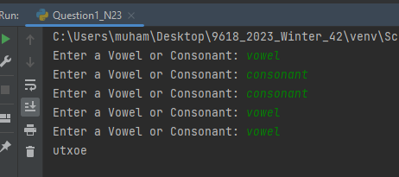

Question 2
Part 2(a)(i)
def IterativeCalculate(Number):
Total = 0
ToFind = Number
while Number != 0:
if ToFind % Number == 0:
Total = Total + Number
Number = Number - 1
return Total

Part 2(a)(ii)
temp = IterativeCalculate(10)
print(temp)

Part 2(a)(iii)
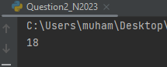

Part 2(b)(i)
def Recursivevalue(Number, ToFind):
if Number == 0:
return 0
else:
if ToFind % Number == 0:
return Number + Recursivevalue(Number -1, ToFind)
else:
return Recursivevalue(Number - 1, ToFind)

Part 2(b)(ii)
temp2 = Recursivevalue(50, 50)
print("Recursive:", temp2)

Part 2(b)(iii)
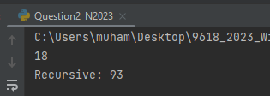

Question 3
Part 3(a)(i)
import datetime

class Character():
#PRIVATE CharacterName : STRING
#PRIVATE DateOfBirth : DATE
#PRIVATE Intelligence : REAL
#PRIVATE Speed : INTEGER

def __init__(self, CharacterNameP, DateOfBirthP, IntelligenceP, SpeedP):
self.__CharacterName = CharacterNameP
self.__DateOfBirth = DateOfBirthP
self.__Intelligence = IntelligenceP
self.__Speed = SpeedP

Part 3(a)(ii)
def GetIntelligence(self):
return self.__Intelligence

def GetName(self):
return self.__CharacterName

Part 3(a)(iii)
def SetIntelligence(self, NewIntelligenceP):
self.__Intelligence = NewIntelligenceP

Part 3(a)(iv)
def Learn(self):
self.__Intelligence = self.__Intelligence + (self.__Intelligence * 0.1)

Part 3(a)(v)
def ReturnAge(self):
Age = 2023 - self.__DateOfBirth.year
return Age

Part 3(b)(i)
FirstCharacter = Character("Royal", datetime.datetime(2019, 1, 1), 70.0, 30)

Part 3(b)(ii)
FirstCharacter.Learn()
Name = FirstCharacter.GetName()
Age = FirstCharacter.ReturnAge()
Intelligence = FirstCharacter.GetIntelligence()
print(Name, "is", Age, "years old and his intelligence is", Intelligence)

Part 3(b)(iii)
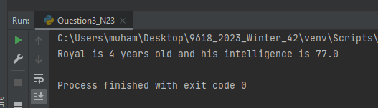

Part 3(c)(i)
class MagicCharacter(Character):
#PRIVATE Element : STRING
def __init__(self, CharacterNameP, DateOfBirthP, IntelligenceP, SpeedP, ElementP):
super().__init__(CharacterNameP, DateOfBirthP, IntelligenceP, SpeedP)
self.__Element = ElementP

Part 3(c)(ii)
def Learn(self):
if self.__Element == "fire" or self.__Element == "water":
newintelligence = super().GetIntelligence() + (super().GetIntelligence() * 0.2)
elif self.__Element == "earth":
newintelligence = super().GetIntelligence() + (super().GetIntelligence() * 0.3)
else:
newintelligence = super().GetIntelligence() + (super().GetIntelligence() * 0.1)

super().SetIntelligence(newintelligence)

Part 3(d)(i)
FirstMagic = MagicCharacter("Light", datetime.datetime(2018, 3, 3), 75.0, 22, "fire")

Part 3(d)(ii)
FirstMagic.Learn()
Name2 = FirstMagic.GetName()
Age2 = FirstMagic.ReturnAge()
Intelligence2 = FirstMagic.GetIntelligence()
print(Name2, "is", Age2, "years old and his intelligence is", Intelligence2)

Part 3(d)(iii)
